Mesh Generation and Adaptivity Tools from the
Terascale Simulation Tools and Technology (TSTT) Center

PIs: J. Glimm^{1,2}, D. Brown³, L. Freitag³, Co-PIs: E. D’Azevedo⁵, P. Fischer⁶, P. Knupp⁴, X.L. Li², M. Shephard⁷, H. Trease⁸, Affiliated Researchers: J. Drake⁵ (Climate), K. Ko⁹ (Accelerators), S. Jardin¹⁰ (CEMM), C. Tzanos⁶ (Combustion)

¹Brookhaven National Laboratory, ²State University of New York at Stony Brook, ³Lawrence Livermore National Laboratory, ⁴Sandia National Laboratories, ⁵Oak Ridge National Laboratory, ⁶Argonne National Laboratory, ⁷Rensselaer Polytechnic Institute, ⁸Pacific Northwest National Laboratory, ⁹Stanford Linear Accelerator Center, ¹⁰Princeton Plasma Physics Laboratory

Our goal is to improve the accuracy and fidelity of PDE-based simulations by bringing modern mesh generation and adaptive mesh tools to the application scientist. Often, however, these sophisticated tools have a level of software implementation difficulty that limits their usage. To address this, we are working closely with SciDAC application teams to enhance mesh generation techniques, improve mesh quality analysis and control, and insert sophisticated adaptive technologies directly into their simulations.

Vision. Many science simulation problems, including those in the SciDAC program, call for sophisticated mesh generation and adaptive mesh refinement technologies. Complex geometrical domains, the need for enhanced resolution in regions where the solution is rapidly changing, or requirements on the quality of the underlying mesh all complicate the numerical simulation of applications based on the solution of partial differential equations. The TSTT Center is working closely with several SciDAC projects and with related application areas and groups to ensure that existing mesh technologies are utilized to their fullest extent. .

Adaptive Mesh Technologies. Many simu-lation problems contain subregions of particular complexity, difficulty, and importance that require enhanced resolution. Adaptive mesh refinement (AMR) tools allow the focusing of simulation effort where it is most needed, and we are applying such tools to accelerator design, climate, and combustion applications.

Accelerator Design: The design process for the next generation of linear accelerators requires accurate prediction of several field quantities that influence wall losses in complex three-dimensional configurations. To obtain the necessary accuracy, TSTT researchers have teamed with scientists at the Stanford Linear Accelerator Center (SLAC) to develop an adaptive mesh control loop based on error indication procedures. TSTT error indicators, field function libraries, and adaptive refinement procedures are used to provide increasingly refined meshes to the SLAC analysis code until a satisfactory result is obtained. The adaptive procedure has been applied to the Trispal cavity for which both experimental measurements and numerical results from standard codes are publicly available. Using only one-third the number of degrees of freedom, the new adaptive procedure reliably provides more accurate predictions than results using uniform refinement. Moreover, in a recent study of four different codes, the TSTT adaptive analysis procedure gave the best agreement to experimental measurements.

Climate. Atmospheric flows over mountain ranges respond dynamically to the variations in height these ranges present. The flow dynamics are thus inherently more complex near such regions, and as a result, the flow simulation is correspondingly more difficult. We are working with climate scientists to develop enhanced mesh generation capabilities for anisotropic planar and geodesic surface meshes. The initial mesh is adapted and optimized to capture land surface orographic or topographic height fields. As the analysis proceeds, solution based adaptation is used to redistribute the mesh nodes in order to minimize solution error. We have successfully demonstrated this technology in prototype simulations and are now working with climate scientists to directly interface the mesh generation and adaptation tools directly with climate codes.

Combustion. This effort has emphasized the break up of a diesel jet into spray. The instability and breakup of a diesel jet is initiated by vortical motion near the jet surface and the injection nozzle walls. These features are about 1/500 of the computational domain size so that AMR is critical to the success of this simulation. We are developing a combined front tracking/AMR scheme and anticipate obtaining a validated, predictive model for the formation of spray, thereby creating a new capability for diesel engine design.

Enhanced Mesh Generation Capabilities. In many applications, the geometric complexity of the computational domain leads to difficulties in the mesh generation process that the TSTT Center is working to address. Of particular note are our efforts in the accelerator design and biology applications.

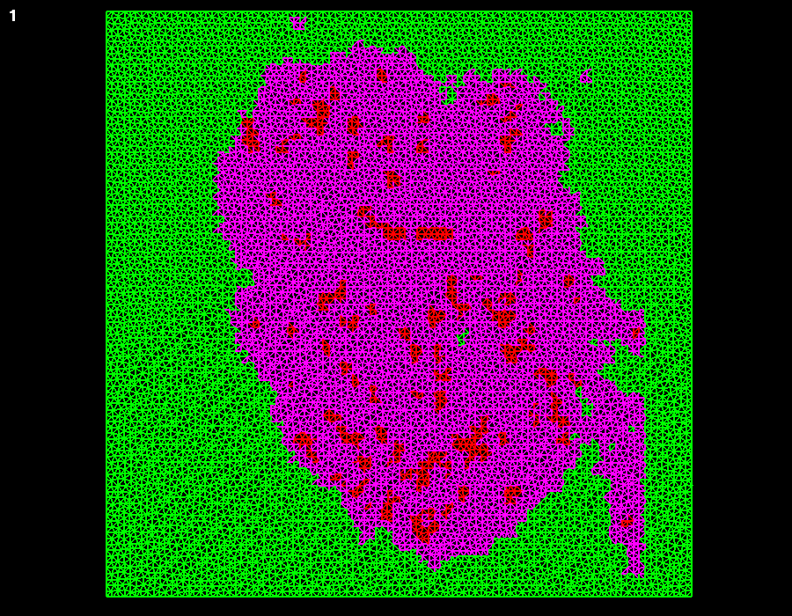
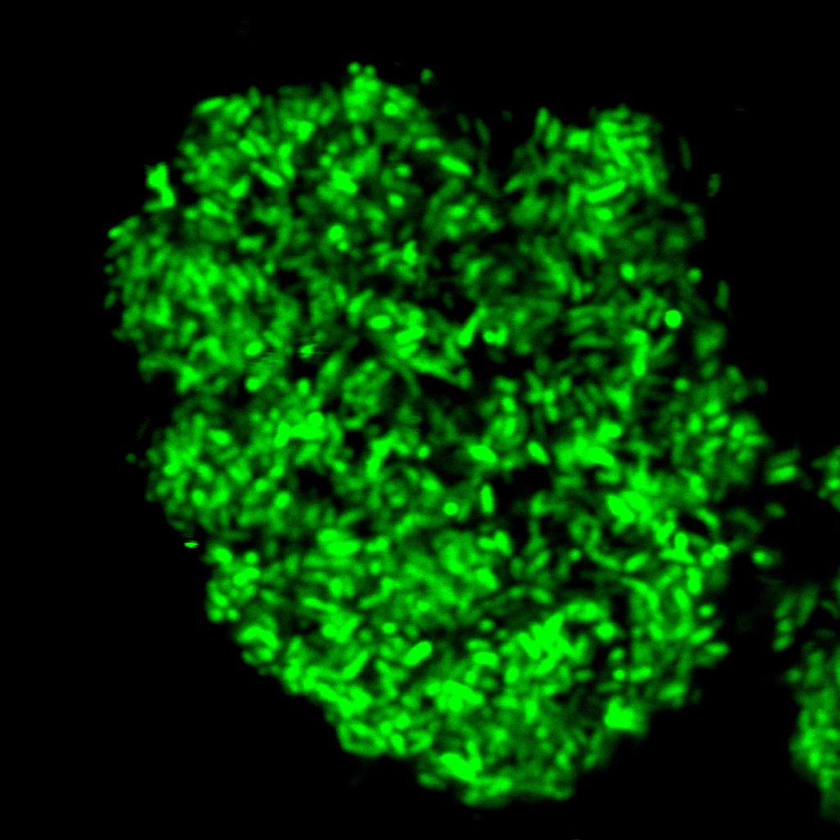
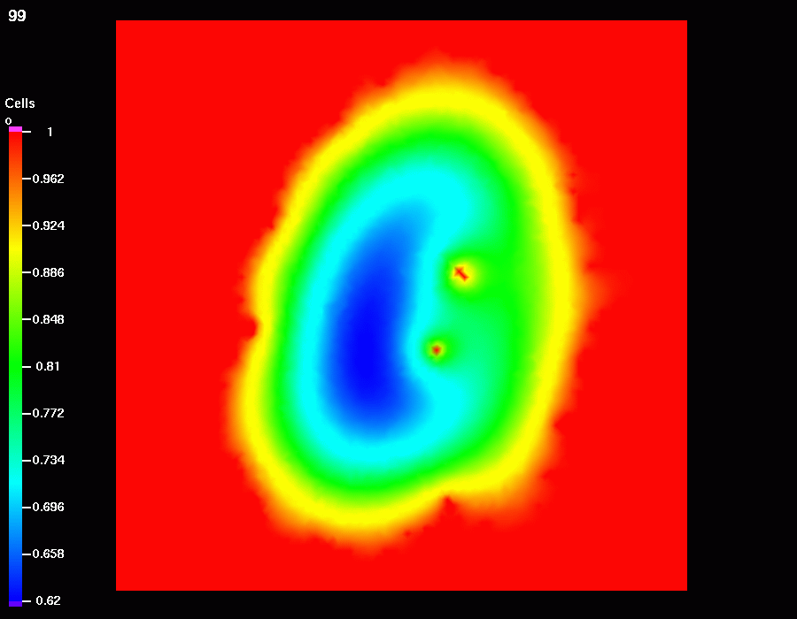
Accelerator design. Accelerating cavities and beamline components have complex boundaries which complicate the process of generating high-quality, computational meshes. We have been working closely with accelerator scientists to help decrease the time needed to generate an initial mesh for these geometries using TSTT mesh generation tools. The generation of an all-hexahedral mesh representing the geometry of the SLAC PEP-II Interaction Region complex enabled the first successful direct calculation of the mode spectrum of this geometry, and resulted in the decision by SLAC to choose the Tau3P electromagnetics code for further PEP-II IR design studies.
Figure 1: Image, mesh and reaction diffusion computation for microbial cell simulations using TSTT mesh generation and discretization technologies

Biology. Certain microbial cells are of great interest to DOE as a possible bioremediation agent for heavy metal waste products. In some instances, these cells flocculate and it is hypothesized that this may be an attempt to shield some individuals from a hostile, high-oxygen environment. To better understand this behavior, we have focused our effort on the development of a computational biology tool called the VMCS (Virtual Microbial Cell Simulator). The VMCS makes use of several TSTT technologies such as unstructured mesh generation, mesh optimization, and TSTT discrete operators. In Figure 1 (left), we show one confocal image slice of the floc which is composed of 10-20 thousand individuals. By stacking such images we can reconstruct the 3D geometry of the floc and generate an unstructured mesh (center). Using this mesh we solve a set of reaction/diffusion equations to get the concentration of oxygen as a function of space and time (right). These calculations confirm that there is an oxygen gradient from the edges of the floc into the center.

Contact Information:
James Glimm, Brookhaven National Laboratory
Phone: 631-333-8155 glimm@bnl.gov
David L. Brown, Lawrence Livermore Nat. Lab
Phone: 925-424-3557 dlb@llnl.gov
Lori Freitag Diachin, Lawrence Livermore Nat. Lab
Phone 925-422-7130 diachin2@llnl.gov

