National Fusion Collaboratory – “Advancing the Science of Fusion Research”

PI: D.P. Schissel,1 Co–PIs: G. Abla,1 J. Burruss,1 S. Flanagan,1
I.T. Foster,3 T.W. Fredian,4 M.J. Greenwald,4 C.R. Johnson,5 K. Keahey,3
S.A. Klasky,7 K. Li,2 D.C. McCune,7 M. Papka, 3 Q. Peng,1 L. Randerson,7
A. Sanderson,5 J. Stillerman,4 R. Stevens,3 M.R. Thompson,6 G. Wallace2
1General Atomics, 2Princeton University, 3Argonne National Lab., 4Massachusetts Institute of Technology, 5University of Utah, 6Lawrence Berkeley National Lab., 7Princeton Plasma Physics Lab.

Summary

The National Fusion Collaboratory is developing a persistent infrastructure to enable scientific collaboration for all aspects of magnetic fusion energy research. Computer scientists and fusion scientists are teaming together to create a robust, user-friendly collaborative software environment and deploying this to the more than one thousand fusion scientists in forty institutions who perform magnetic fusion research in the United States. This activity is transforming the way fusion does business and is ultimately accelerating understanding and innovation towards the design of an attractive new fusion energy source.

Developing a reliable energy system that is economically and environmentally sustainable is the long–term goal of Fusion Energy Science (FES) research. In the U.S., FES experimental research is centered at three large facilities with a replacement value of over $1B. As the experiments performed at these facilities have increased in size and complexity there has been a concurrent growth in the number and importance of collaborations among large groups at the experimental sites and smaller groups located nationwide. Teaming with the experimental community is a theoretical and simulation community whose efforts range from the applied analysis of experimental data to the development of fundamental theory (e.g., creation of realistic nonlinear 3D plasma models). As a result of the highly collaborative nature of FES research, the community is facing new and unique challenges.

The SciDAC-funded National Fusion Collaboratory (NFC) Project unites fusion and computer science researchers to directly address these challenges. The overall goal of the NFC project is to improve the productivity of fusion sciences research via the development and deployment of advanced software tools that reduce the technical barriers to collaboration and sharing on a national scale. Our vision is to make resources – data and computers along with analysis, simulation, and visualization codes – widely and transparently available as network-accessible services, thereby enabling real-time multi-institutional collaboration on fusion experiments, and facilitating more direct comparisons between experiments and theory.

To achieve these goals, the NFC project is integrating advances in computer science such as grid middleware, experiment-specific applications and computing, storage resources, and advanced collaborative environments to bring effective end-to-end capabilities to the scientist. This work has led to the creation and usage of a national FES “Grid” (FusionGrid or FG) that is a system for secure sharing of computation, visualization, and data resources over the Internet.
Most recently, FusionGrid services were integrated together for a demonstration of the collaborative fusion experimental control room that requires rapid data analysis that can be assimilated in near real time by a geographically dispersed research team. Access Grid technology was used to allow for shared audio and video as well as shared applications. Time-critical off-site data analysis in support of the experiment was conducted on FG through a computational reservation system that guaranteed analysis in a specified time window. A tiled display wall was used to enhance the collaborative work environment within the control room through application sharing. The SCIRun visualization tool facilitated the near real-time comparison of predictive simulations with experimental data.
Three accomplishments that highlight the success of the NFC project are;
- The data repositories of the 3 main U.S. fusion experiments are securely available worldwide via FG.
- Over 1500 fusion plasma simulations were run 20 times faster using an FG code service (10,000 CPU hours for 9 different U.S. and European fusion devices).
- Rather than travel, a San Diego scientist used FG services to remotely lead the JET fusion experiment located in England.
Near-term work by the NFC project includes the usage of the collaborative control room during actual experiments at the 3 main U.S. sites as well as the leadership of the DIII-D experiment in San Diego by a remote team of Japanese collaborators. Feedback from this real-world experience will be used to modify FG services to provide maximum benefit for the fusion scientist. Critical areas of future work also include adding more services to FG, increasing data throughput capabilities to effectively handle large simulations, and ease-of-use issues. Ease-of-use related to security and adding new services is even more important as the number of scientists using FG increases.
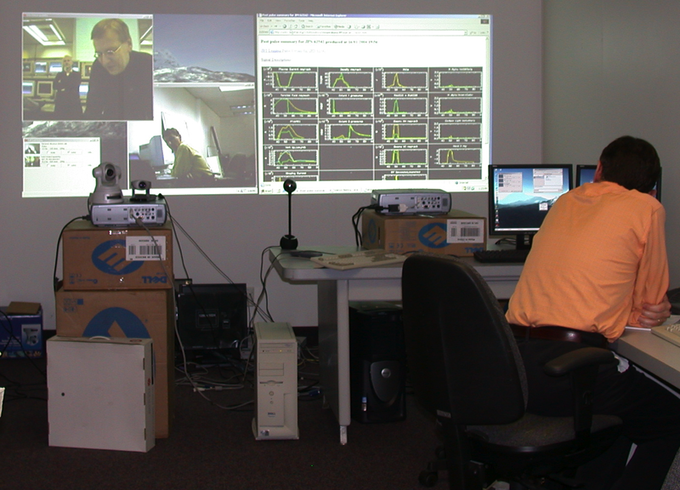Figure 1. FusionGrid services were recently used by a scientist in San Diego to lead the JET fusion experiment in England.
The collaborative technology being deployed by the NFC is scalable to fusion research well beyond the present U.S. program. As specified by the US DOE Facilities for the Future Report, the two highest priorities for the Office of Science are the next-generation fusion experimental device ITER and the Ultra Scale Computing Capability (USSCC) to increase scientific computing, including fusion-related, by a factor of 100. Key to the success of these facilities is collaborative technology like that being developed by the NFC.
In recognition of the importance of our work, the NFC project was asked by ITER to present the collaborative control room concept. This concept is now being discussed as the model for organizing the worldwide scientific collaborations that will be required for the success of ITER.
For further information on this subject contact:
David P. Schissel, Lead–PI
National Fusion Collaboratory SciDAC Project
http://www.fusiongrid.org/project/
Phone: 858-455-3387
Schissel@fusion.gat.com

