
Magnetic Reconnection

Center for Magnetic Reconnection Studies (CMRS)
PI and Project Director: A. Bhattacharjee (University of New Hampshire)
PI: R. Rosner (University of Chicago), PI: R. Fitzpatrick (University of Texas at Austin)
Affiliated Researchers: N. Bessho, K. Germaschewski, C. S. Ng, P. Zhu (University of New Hampshire); T. Linde and L. Malyshkin (University of Chicago); F. Waelbroeck and P. Watson (University of Texas at Austin)
D. Keyes and B. Smith (TOPS: Terascale Optimal Partial Differential Equation Simulations)

Summary. The CMRS is a multi-institutional consortium (University of New Hampshire, University of Chicago, and the University of Texas at Austin) dedicated to physical problems involving magnetic reconnection in fusion, space, and astrophysical plasmas.

Understanding magnetic reconnection is one of the principal challenges in plasma physics. Reconnection is a process by which magnetic fields reconfigure themselves, releasing energy that can be converted to particle energies and bulk flows. Thanks to the availability of sophisticated diagnostics in fusion and laboratory experiments, in situ probing of magnetospheric and solar wind plasmas, and X-ray emission measurements from solar and stellar plasmas, theoretical models of magnetic reconnection can now be constrained by stringent observational tests. The members of the CMRS comprise an interdisciplinary group drawn from applied mathematics, astrophysics, computer science, fluid dynamics, plasma physics, and space science communities.

Recent developments in the theory of Hall magnetohydrodynamic (MHD) reconnection hold the promise for providing solutions to some outstanding problems in fusion, space and astrophysical plasma physics. While significant analytical and numerical progress has been made, we have been limited so far in our ability to settle definitively several outstanding questions because of the lack of adequate scale separation and resolution in simulations. The principal computational product of the CMRS---the Magnetic Reconnection Code (MRC)---is a state-of-the-art, large-scale Hall MHD code that will carry magnetic reconnection research to the next level of accuracy and completeness in 2D and 3D, with the multi-scale separation and spatio-temporal resolution required to be directly applicable to experiments and observations. The MRC is massively parallel and modular, has the flexibility to change algorithms when necessary, and uses Adaptive Mesh Refinement (AMR). The basic strategy for parallel processing within AMR is to treat every subgrid as an independent task on a processor, with communication and synchronization between different processors based on the Message Passing Interface (MPI). In order to make the communication between processors as efficient as possible, we use a novel method based on Hilbert-Peano space-filling curves which keep clusters of neighboring grids on the same processor. We make extensive use of state-of-the-art numerical methods that have been shown in the last decade to combine excellent shock-capturing properties with robustness and simplicity.

One of the great strengths of the SciDAC program is that it provides a unique opportunity for physicists to work with applied mathematicians and computer scientists. A major challenge for the
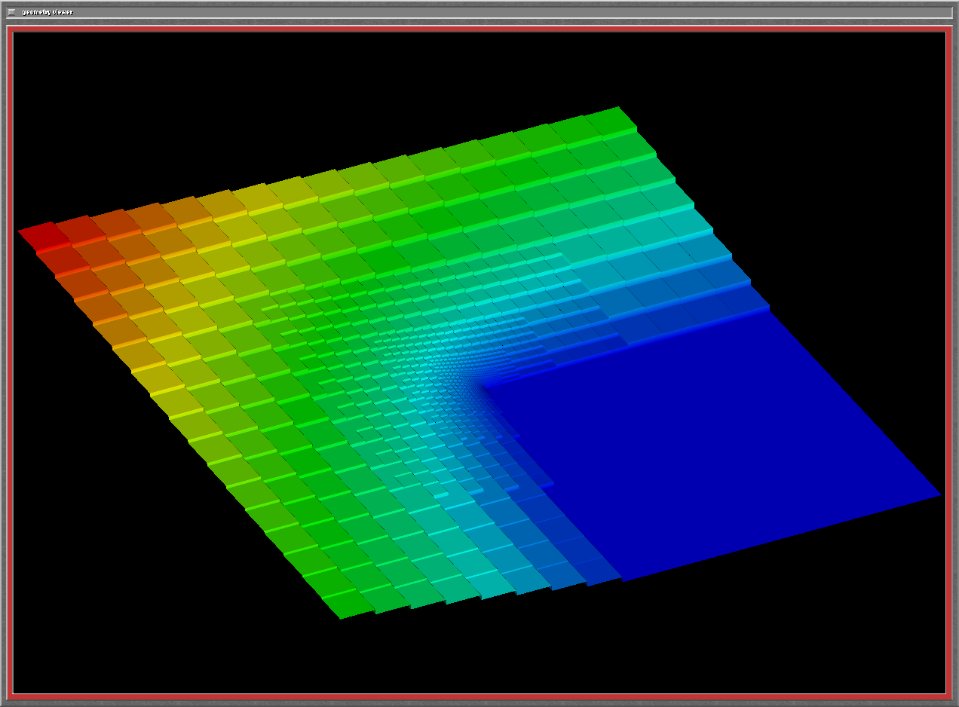

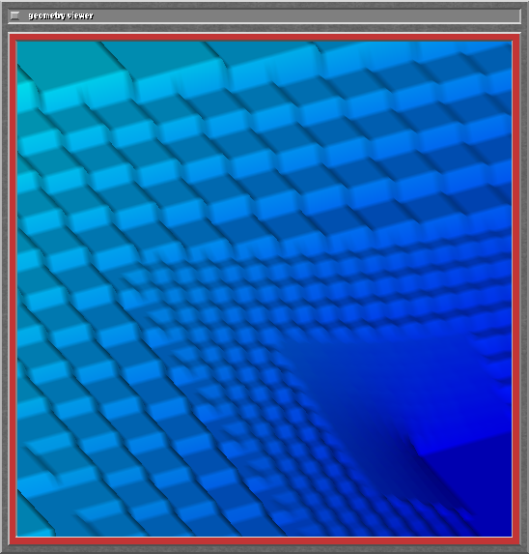

Figure 1. AMR allows us to place refined numerical grids automatically where the fine spatial structures requires them, as shown in the figure where sharp spatial gradients at the center are resolved by placing refined grids (see inset for zoom), Our AMR code has the capability to refine not only in space but also in time, which is more efficient since one does not need to take unnecessarily small time steps in regions where the fields are smooth.

numerical integration of the Hall MHD equations is the need to solve elliptic equations on the grid hierarchy generated by the AMR framework. We integrate our algorithm within the PETSc toolkit developed by the SciDAC TOPS group, and exploit PETSc's optimized computational kernels and integrated parallelization support. The MRC has been run on a hierarchy of fully refined grids and shown to scale satisfactorily up to the highest used processor count of 1024 on NERSC's IBM SP machine, Seaborg. We are presently collaborating with colleagues in the TOPS group in the development of fully implicit numerical methods. Development of implicit methods in an AMR framework in arbitrary geometry is key to several physical applications involving reconnection.

Using the MRC, with its flexible range of algorithms, we can now explore the effects of various types of boundary conditions, expand the range of aspect ratios in the chosen computational geometry, and investigate a wide regime of plasma pressure, resistivity, and electron and ion inertial scales. We have applied the MRC to a wide spectrum of physical problems: internal disruption (Figure 2) and error-field induced islands in tokamaks, storms in the magnetosphere, solar/stellar flares, and vortex singularity formation in fluids.

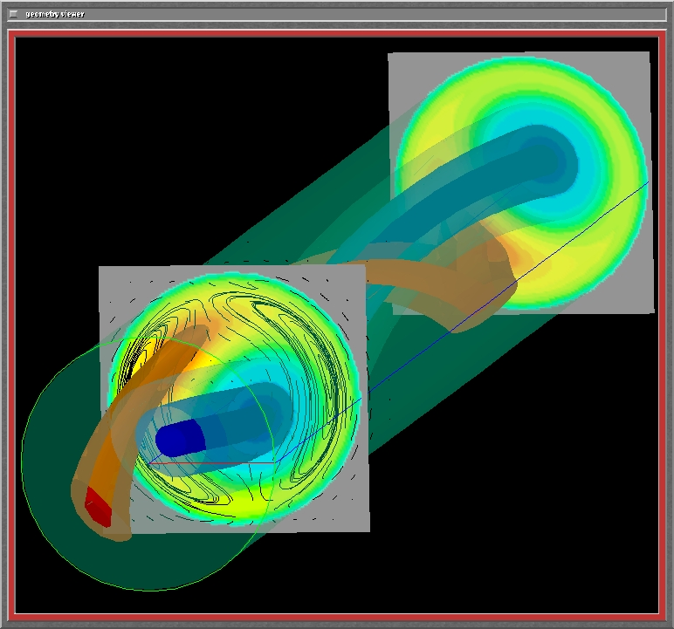

Figure 2. A Hall MHD simulation of the so-called kink-tearing instability in tokamaks that can cause internal current disruption and core temperature collapse. The two intertwining helical flux tubes are formed as a result of reconnection, and their 2D projections show magnetic island structure. The black lines in the leading projection show the plasma flow streamlines.

For further information on this subject contact:
Prof. Amitava Bhattacharjee, Project Director
Center for Magnetic Reconnection Studies
EOS Institute, University of New Hampshire
Durham, NH 03824
Amitava.Bhattacharjee@unh.edu
http://reconnect.sr.unh.edu/cmrs/

