The Applied Partial Differential Equations Center (APDEC): an Integrated Software Infrastructure Center for Block-Structured Adaptive Mesh Refinement

Principal Investigators: J. Bell, P Colella, M. Berger, L. Diachin, M. Minion, E.G. Puckett, C. Rutland, R. Samtaney. Applications Collaborators: E. Esarey, S. Jardin, W. Leemans, R. Ryne.

Summary
The goal of this project is to develop a high-performance algorithmic and software framework for multi-scale problems in three important DOE mission areas (magnetic fusion, accelerator design, and combustion) based on the use of block-structured adaptive mesh refinement (AMR) for representing multiple scales. We are taking an end-to-end approach to applying AMR to these problem areas, developing new self-contained simulation capabilities in collaboration with investigators in the applications fields.

Many important DOE applications can be described mathematically as solutions to partial differential equations exhibiting multiscale behavior. Combustion for energy production and transportation is dominated by the interaction of fluid dynamics and chemistry in localized flame fronts. Fueling of magnetic fusion devices involves the dispersion of material from small injected fuel pellets. The successful design of high-intensity particle accelerators relies critically on the ability to accurately predict the space-charge fields of localized beams in order to control the beams, preserve the beam emittance, and minimize particle loss.

In this project, we are developing a new class of simulation tools for these and other multi-scale problems. These tools are
based on the use of block-structured adaptive mesh refinement (AMR) to represent multi-scale behavior. In this approach, the physical variables are discretized on a spatial grid consisting of nested rectangles of varying spatial resolution, organized into blocks. This hierarchical discretization of space can adapt to changes in the solution to maintain a uniform level of accuracy throughout the simulation. We also can vary the temporal resolution to match the spatial resolution.
Finally, complex boundary geometries can be treated using an embedded boundary approach, in which the irregular boundary is represented by its intersection with the rectangular grid. The use of AMR can increase by orders of magnitude the range of length scales that can be resolved in a simulation, in comparison with traditional fixed-grid approaches.
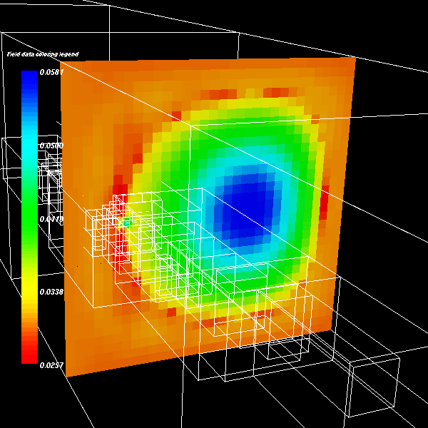

Figure 1. AMR simulation of a fuel pellet being injected into a tokomak. Image shows the pressure along a slice as well as the outlines of the various refined grid patches. (collaboration with the SciDAC CEMM project).

The use of AMR requires the consideration of new mathematical, algorithmic, and software issues in order to represent the coupling between different scales. For that reason, we have taken an end-to-end approach, developing self-contained new simulation capabilities based on AMR.

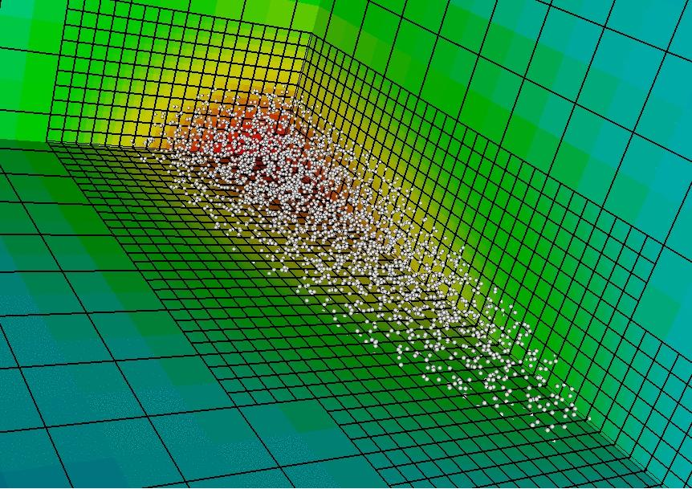

Figure 2. AMR particle-in-cell calculation, showing on the slices the electrostatic field
induced by the particles.(Collaboration with the SciDAC AST project).

These include simulation codes for non-ideal magnetohydrodynamics problems arising in magnetic fusion (Figure 1); AMR-PIC codes for computing particle-in-cell space charge effects for beam dynamics in accelerator design problems (Figure 2); an AMR embedded boundary code for

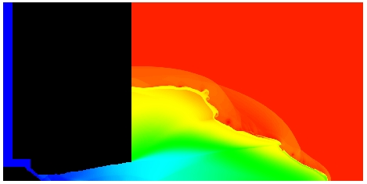

Figure 3. Axisymmetric gas jet expanding into a vacuum, with the axis of symmetry along the bottom of the figure. The calculation was performed using an embedded boundary AMR method (the
irregular boundary is shown in black).
(Collaboration with the SciDAC AST project).

simulating gas jets in laser-driven plasma-wakefield accelerators (Figure 3); and AMR combustion codes simulating turbulent combustion in laboratory-scale flames (Figure 4). Although these applications are quite diverse physically, there is considerable overlap in their mathematical structure. We have developed a component design for our software based on that common mathematical structure to maximize reuse across applications, as well as portability across platforms. We are also building interfaces to other related software
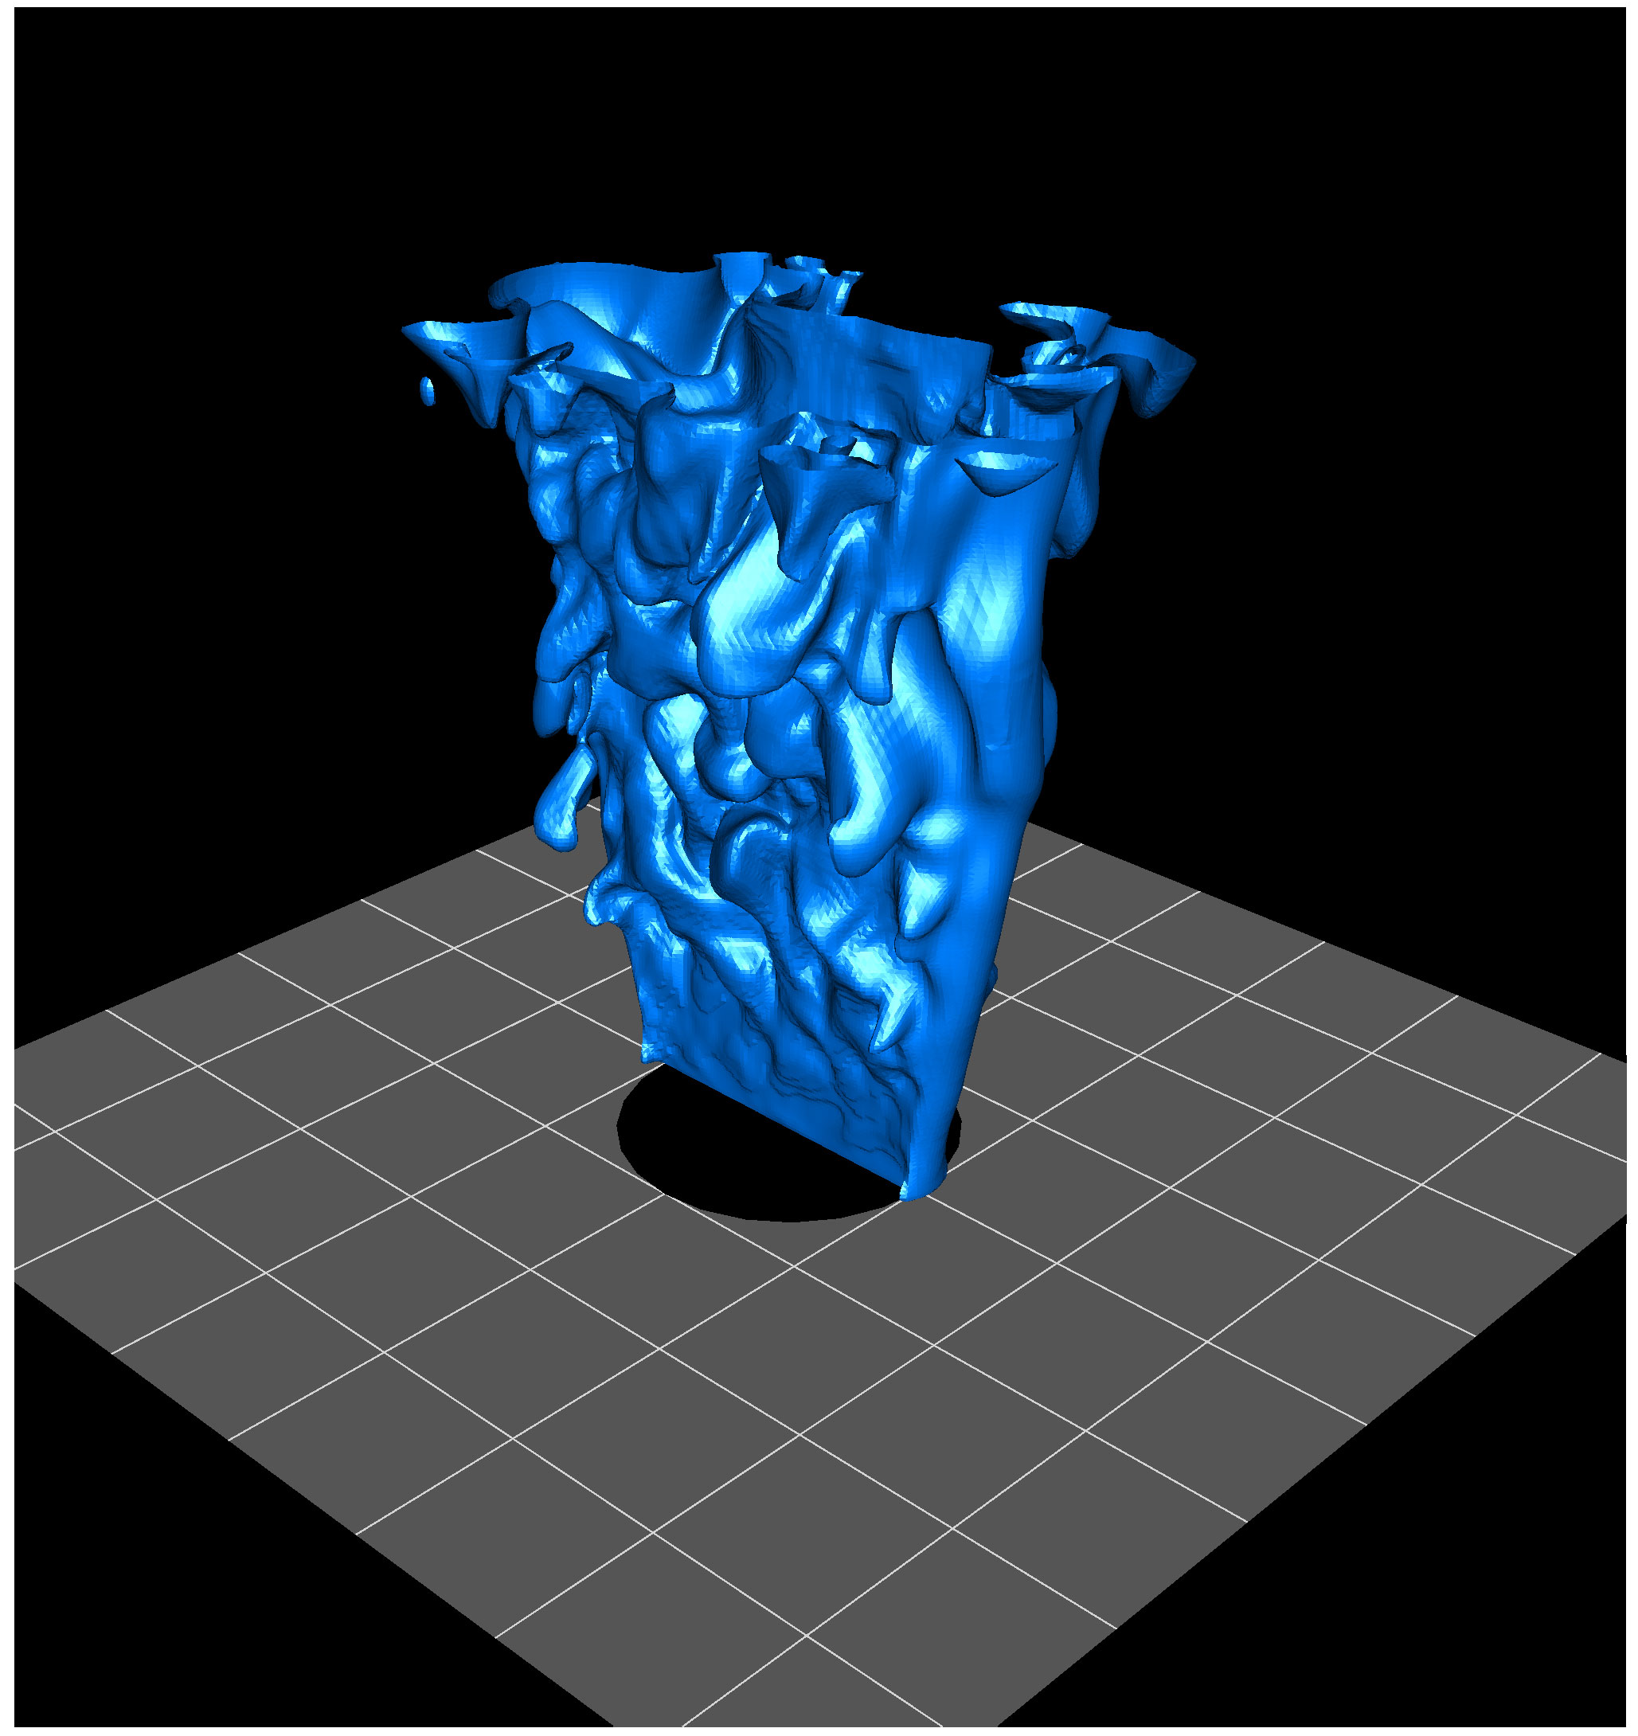

Figure 4. High-resolution simulation of laboratory-scale turbulent methane flame, computed using an AMR algorithm for low-Mach number combustion with detailed chemistry and transport.

packages, such as solver packages being developed by the TOPS ISIC and the NASA Cart3D grid generation package. Finally, we are developing interoperability standards and tools for AMR codes in collaboration with the CCTTSS ISIC.

Over the next year, our primary focus will be on hardening the toolset we have developed, and further development of applications capabilities based on these tools.

For further information on this subject contact:
Phillip Colella
Lawrence Berkeley National Laboratory
Phone: 510-486-5412
E-mail: Pcolella@lbl.gov
Project web site: http://davis.lbl.gov/APDEC

