Developing Interoperable Meshing and Discretization Technologies in the Terascale Simulation Tools and Technology (TSTT) Center

PIs: J. Glimm^{1,2}, D. Brown³, L. Freitag³, Co-PIs: E. D’Azevedo⁵, P. Fischer⁶, P. Knupp⁴, X.L. Li², M. Shephard⁷, H. Trease⁸ Affiliated Researchers: R. Armstrong⁴ (CCA), G. Kumfert³ (CCA), T. Epperley³ (CCA), T. Dahlgren³ (CCA), T. Munson⁶ (TOPS)

¹Brookhaven National Laboratory, ²State University of New York at Stony Brook, ³Lawrence Livermore National Laboratory, ⁴Sandia National Laboratories, ⁵Oak Ridge National Laboratory, ⁶Argonne National Laboratory, ⁷Rensselaer Polytechnic Institute, ⁸Pacific Northwest National Laboratory

The primary technology goal of the TSTT center is to eliminate the barriers associated with using sophisticated meshing and discretization tools in an interoperable and interchangeable way in application solution. To make this goal a reality, we are addressing several different aspects of the problem from demonstrations of one-on-one tool interoperability to the development of a common interface for existing TSTT mesh management tools and the creation of new technologies to enable hybrid solution strategies.

Vision. Application scientists in many different areas can reach new levels of understanding through the use of high-fidelity calculations based on solving partial differential equations that model multiple coupled physical processes and multiple interacting physical scales. The optimal route to superior results in many application areas, and frequently the only way to obtain useful answers, is to use approaches that combine many different types of meshes and solution strategies into one simulation. Unfortunately, most modern meshing and discretization technologies are not interoperable, making it extremely difficult to pursue these strategies. The Terascale Simulation Tools and Technologies (TSTT) Center recognizes this critical gap and is addressing the technical and human barriers preventing the effective use of powerful composite and hybrid methods.

TSTT technology development efforts fall into three broad categories: 1) the creation of common interfaces for mesh, geometry and field data, 2) demonstrations of one-on-one tool interoperability, and 3) the development of new technologies to enable hybrid solution processes.

Common Interface Definition.

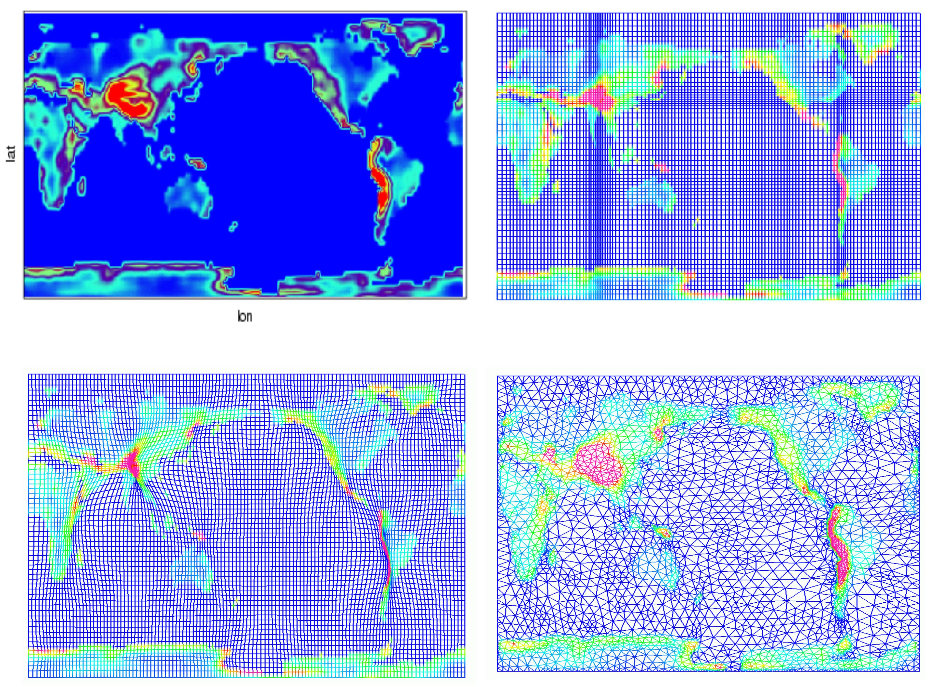
There are a wide array of mesh and discretization strategies available to solve application problems and many times it is not clear a priori which is the best strategy for a particular simulation. See Fig 1. The only way to determine the proper choice is to experiment with a number of options. This is both time- consuming and difficult because most mesh and discretization tools have very different programming interfaces. To enable this kind of experimentation, and as a first step toward interoperability, the TSTT team is developing a common software interface for its many mesh, geometry and field management infrastructures. A key aspect of our approach is that we do not enforce any particular data structure or implementation with our interfaces, only that certain questions about the mesh can be answered through calls to the interface. The challenges inherent in this type of effort include balancing performance of the interface with the flexibility needed to support a wide variety of mesh types. Further challenges arise when considering the support of many different scientific programming languages. This aspect is addressed through our joint work with the Center for Component Technologies for Terascale Simulation Science (CCTTSS) to provide language independent interfaces using their SIDL/Babel technology. Efforts to implement this specification are underway at most TSTT sites and additional efforts that use the interface to support interoperability in front tracking and mesh quality improvement algorithms are ongoing.
Fig. 1 A common interface would allow these three mesh types to be used interchangeably within a climate simulation.

One-to-One Tool Interoperability.

To show-case the potential payoff for a software environment that supports interoperable meshing and discretization software, we have engaged in
research activities that target one-to-one interoperability between TSTT tools. The most notable of these is the ongoing work to merge the FronTier front-tracking code with the Overture adaptive mesh management framework. The front-tracking methods developed within FronTier exactly follow the sharp interfaces between two different materials and have been used in a number of different scientific problems. The adaptive mesh refinement (AMR) techniques within Overture are used to automatically insert more grid points only in regions where increased resolution is required. By combining the strengths of these two methods, we have developed a new AMR front tracking algorithm that simultaneously provides more accurate and computationally efficient methods, thereby enabling improved simulations of diesel jet spray breakup.

New Technology Development. In addition to combining existing technologies to enable hybrid solution strategies, new technology is also being developed. Our two primary efforts to date include the MESQUITE mesh quality improvement toolkit and demonstrations of hybrid discretization techniques.

MESQUITE: To improve the quality of meshes generated by TSTT tools, we are developing a freely available, comprehensive software package called MESQUITE that accommodates a number of different mesh element types, quality metrics, and state-of-the-art algorithms. A new, highly effective node point movement algorithm has been developed in conjunction with the TOPS center. MESQUITE is compliant with the TSTT mesh interface and is used with a number of TSTT mesh generation tools.

Discretization Techniques: The complexities of discretizing new applications on unstructured and adaptively evolving grids have hampered widespread usage of many powerful discretization tools. We are working to separate low-level operators from existing TSTT frameworks and reimplement them into a Discretization Library. This library will be compliant with the TSTT interface so that application scientists can easily experiment with a number of different discretization technologies. New work is demonstrating the effectiveness of a hybrid solution approach that combines structured and unstructured discretization technologies in electromagnetics applications.

Future Plans. The TSTT center will continue development of new technologies to better enable hybrid solution strategies. Our common interface definition efforts will focus on the creation of interfaces that support parallel computing and the interactions among the mesh, geometric domain, discretization library, and application field data. We will use newly developed technologies such as AMR front tracking techniques and MESQUITE to impact SciDAC applications and as a showcase to highlight the promise of interoperable meshing and discretization. We will work with application scientists to develop new codes that use hybrid solution strategies to solve previously intractable physics problems.

Further Information: http://tstt-scidac.org

Contact Information:

James Glimm, Brookhaven National Laboratory
Phone: 631-333-8155 glimm@bnl.gov

David L. Brown, Livermore National Laboratory
Phone: 925-424-3557 dlb@llnl.gov

Lori Freitag Diachin, Livermore National Laboratory
Phone: 925-422-7130 diachin2@llnl.gov

